


Digital Scheme Book

Scheme Name: Ross Walk Housing Cooperative managed by PA Housing
Housing Management Officer: Vacant ( contact krishan Mistry)
Neighbourhood: Belgrave, Leicester LE4 postcodes – see map
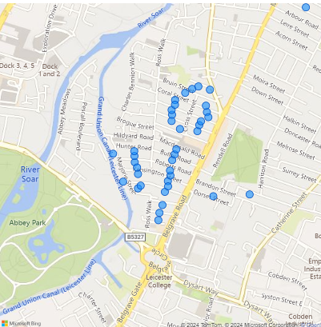

Date last updated:
17/08/2026

Contents

Estate Photos - Exterior 2
Estate Photos - Exterior 4
Estate Photos - Exterior 5
Estate Photos - Exterior 6
Estate Photos - Exterior 7
Estate Photos - Exterior 8
Estate Photos – Belgrave Neighbourhood Community Centre 9
Estate Photos – Wolsey Building for surgery 10
Estate Photos – Wolsey Building for surgery 11
Estate Photos – Wolsey Building for surgery 12
Estate Details 13
Legal/Ownership 13
Managing Agent Company Information 13
Residents Association & Neighbourhood Champions 13
Local Authority Details & Contacts 13
Local Authority Specific Contacts 14
Site Office 14
Add Ross Walk website address: 14

Estate Photos - Exterior

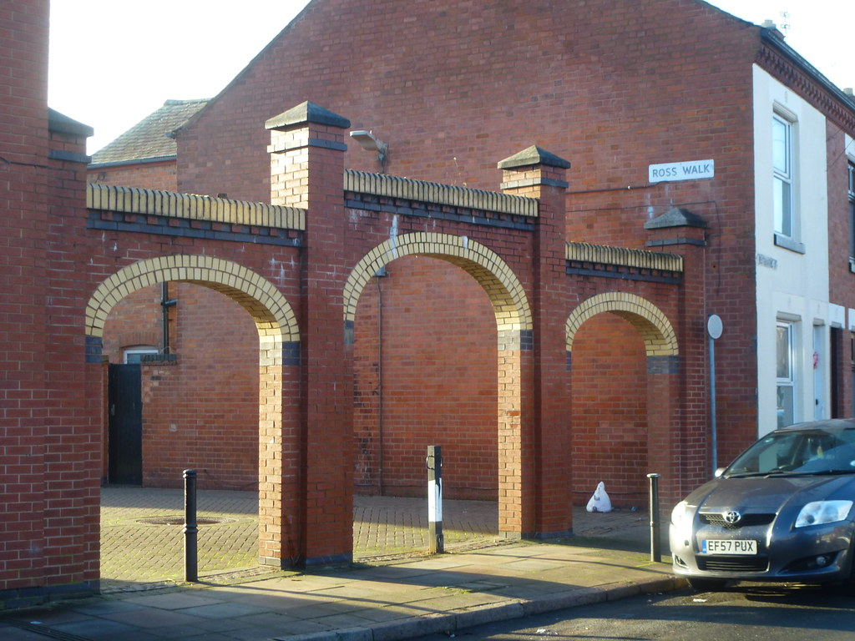Ross Walk Arch Way

Estate Photos - Exterior

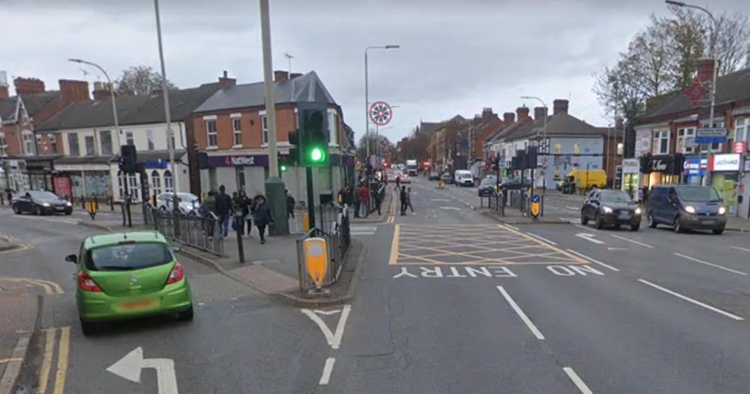

Loughborough Road – Melton Road Junction

Estate Photos - Exterior



MacDonald Road

Estate Photos - Exterior



Garfield Street

Estate Photos - Exterior

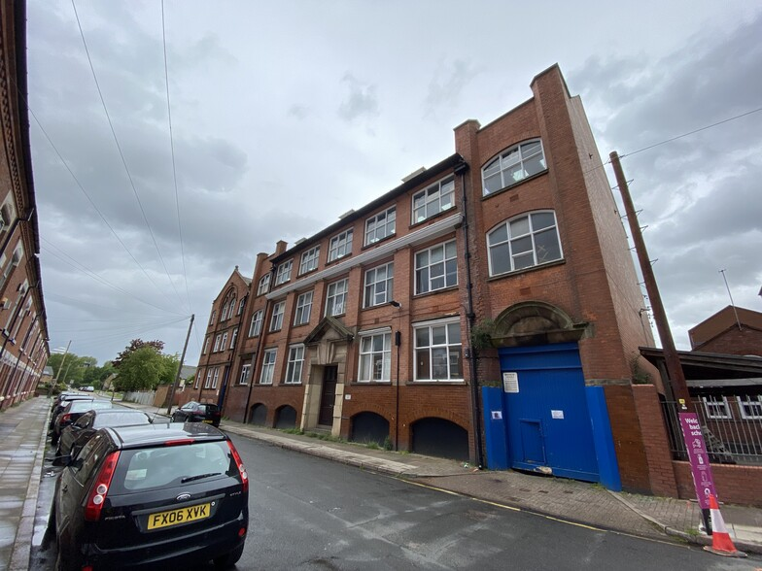

Bruin Street, Leicester

Estate Photos - Exterior



Belgrave Health Centre

Estate Photos – Belgrave Neighbourhood Community Centre



Estate Photos – Wolsey Building for surgery

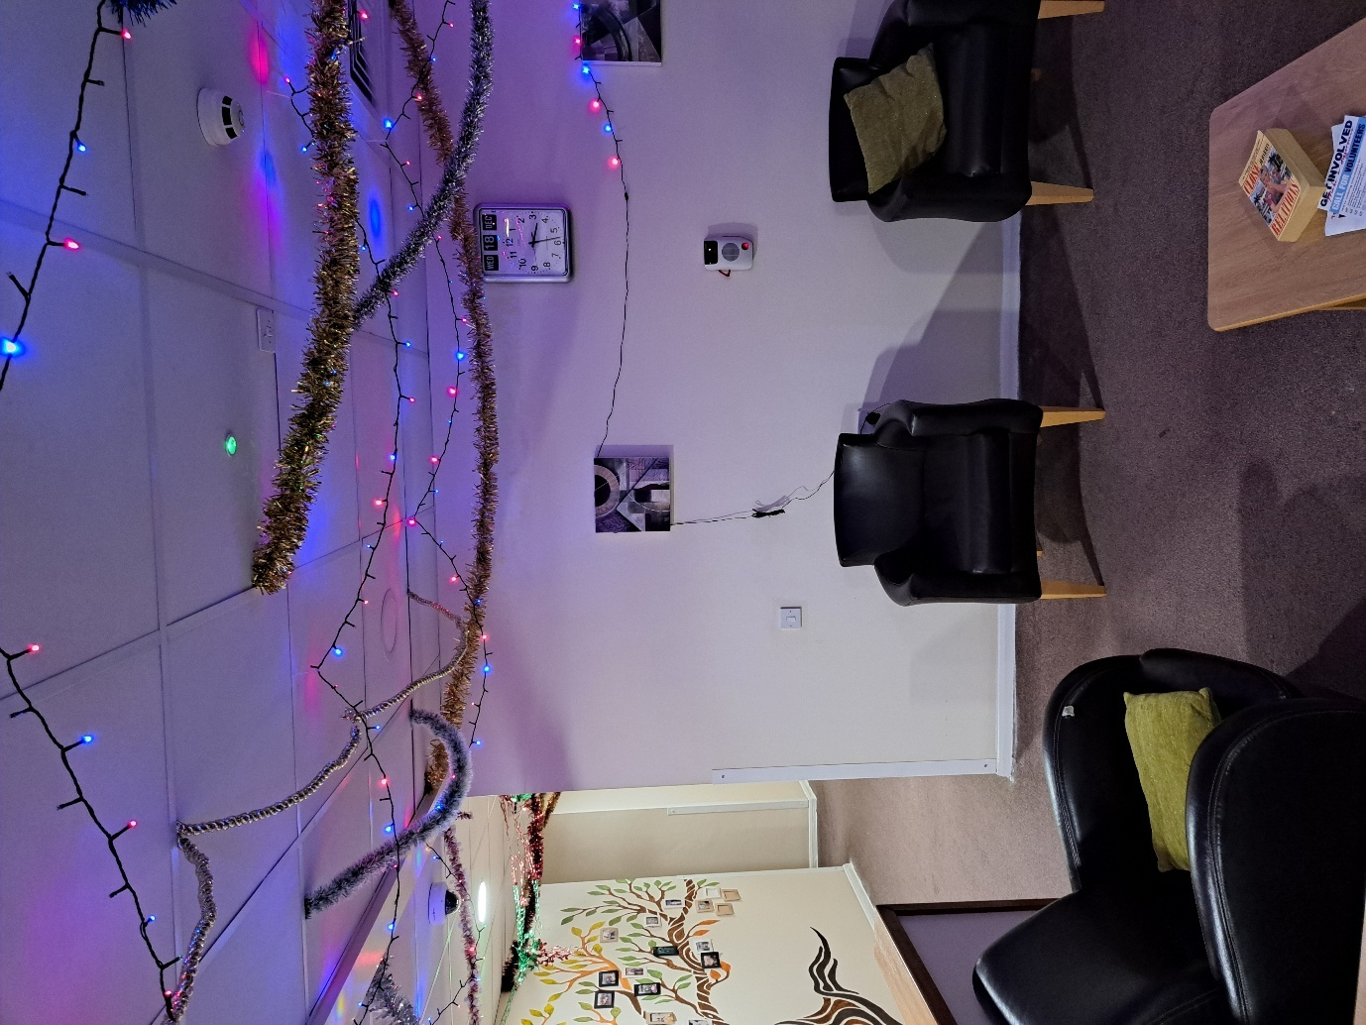

Estate Photos – Wolsey Building for surgery

Estate Photos – Wolsey Building for surgery

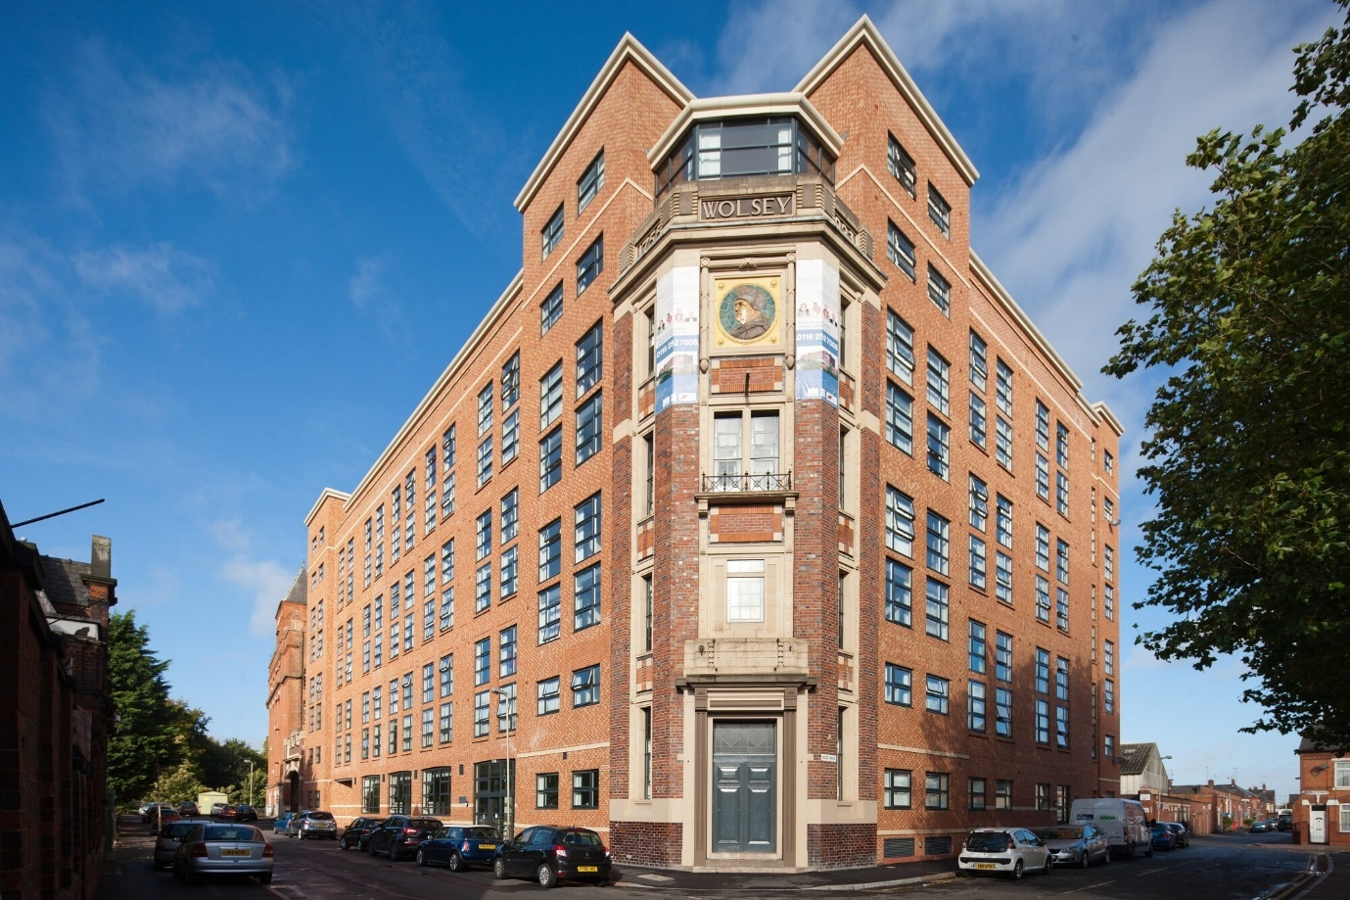

Estate Details
Housing Management Officer | Vacant contact krishan mistry
Email Address: | Krishan.mistry@pahousing.co.uk
Phone Number: | 01162576800 /07514664003
Estate Name: | Ross Walk Housing Cooperative
Full Address: | Homes in the LE4 Belgrave area of Leicester
Estate Reference Number:
Number of Units: | 121
Number of General needs units: | All are general needs family houses
Number of shared Owners: | 0
Number of Leaseholders: | 0

Legal/Ownership
FreeHolder: | All owned by Ross Walk Housing Cooperative

Managing Agent Company Information
Managing Agent Company Name: | PA Housing
Contact: | 3 Bede Island Road Leicester LE2 7EA
Email Address: | coops@pahousing.co.uk
Phone Number: | 01162576800
Responsibility of Managing Agent: | All services to Ross Walk Cooperative

Residents Association & Neighbourhood Champions
Residents Association: | Maynard Committee
Neighbourhood Champions: | Mr Kishor Jadavji
Email Address: | coops@pahousing.co.uk
Phone Number: | 01162576800

Local Authority Details & Contacts
Local Authority: | Leicester City Council
Local Councillors: | Shital Adatia, Yogesh Chauhan, Jaiantilal Gopa
Email Address: | Shital.Adatia@leicester.gov.uk  Yogesh.Chauhan@leicester.gov.uk  Jaiantilal.Gopal@leicester.gov.uk
Phone Number: | 07742 766459; 07742 766441; 07742 766455

Local Authority Specific Contacts

Safer Neighbourhoods Team: | Belgrave South | Your area | Leicestershire Police | Leicestershire Police
Safeguarding: | Leicester City Council - 0116 454 1004, Adult or Leicestershire Police
Mental Health: | Mental Health Central Access Point on 0808 800 3302. Provided by Leicestershire Partnership NHS Trust.
PCSO: | Belgrave South | Your area | Leicestershire Police | Leicestershire Police

Site Office
Scheme Office: | Wolsey Building - Hobby Room,  11 Abbey Park, Leicester, LE4 5AF
Hours of Scheme | 2pm – 4.30pm Every Wednesday
Contact: | Krishan Mistry
Email Address: | coops@pahousing.co.uk
Phone Number: | 01162576800 / 07514664003

Add Ross Walk website address:
Stock information:
Bedrooms | 2 bedroom | 3 bedroom | 4 bedroom
Number of homes | 75 | 41 | 5

